Op Amp Design Project

Chris Washington

ELEN 326-501

Table of Contents

Table of Contents 2
Performance 3
Measurements 3
Circuit/Plots 4
Circuit 1 - Op Amp (Unity Gain Feedback): 4
Plot 1 - AC Analysis (Bode Plot): 5
Plot 2 - DC Sweep (DC Voltage Gain): 6
Plot 3 - Transient Analysis (Slew Rate Falling): 7
Plot 4 - Transient Analysis (Slew Rate Rising): 8
Comments 8

Performance

ITEM | Spec/Calculated | Predicted/Used | Measured
GB | 1.00MHz | - | 1.19MHz
A_{o} | 60dB | - | 60.15dB
I_{b} | 20μA | - | 20.83μA
PM | 60º | - | 60º
SR(rising) | 2V/μs | - | 2.15V/μs
SR(falling) | 2V/μs | - | 2.38V/μs
R_{C} | 1.45kΩ | 1.45kΩ | 1.45kΩ
Power | 250μW | 245.36μW | 214.0μW
α | 1.79 | - | 1.676
g_{m1/2} | 62.832μA/V | - | 62.832μA/V
g_{m6} | 138μA/V | - | 138μA/V

Performance Items

Measurements

 | Calculated | Used
AR₁ | 3.42 | 3.8
W₁ | 3.4 | 3.8
L₁ | 1.0 | 1.0
AR₂ | 3.42 | 3.8
W₂ | 3.4 | 3.8
L₂ | 1.0 | 1.0
AR₃ | 0.52 | 0.63
W₃ | 1.0 | 1.0
L₃ | 2.0 | 1.6
AR₄ | 0.52 | 0.63
W₄ | 1.0 | 1.0
L₄ | 2.0 | 1.6
AR₅ | 4.63 | 5.5
W₅ | 7.4 | 8.8
L₅ | 1.6 | 1.6
AR₆ | 1.88 | 1.88
W₆ | 3.0 | 3.0
L₆ | 1.6 | 1.6
AR₇ | 4.5 | 5.5
W₇ | 1.8 | 2.2
L₇ | 0.4 | 0.4
AR₈ | 4.5 | 4.5
W₈ | 1.8 | 1.8
L₈ | .04 | 0.4
Design Values

Circuit/Plots

Op Amp Circuit | Circuit 1 | Transient | Plot 3
DC Sweep | Plot 1 | Transient (rising) | Plot 4
AC Sweep | Plot 2
List of Figures

Circuit 1 - Op Amp (Unity Gain Feedback):

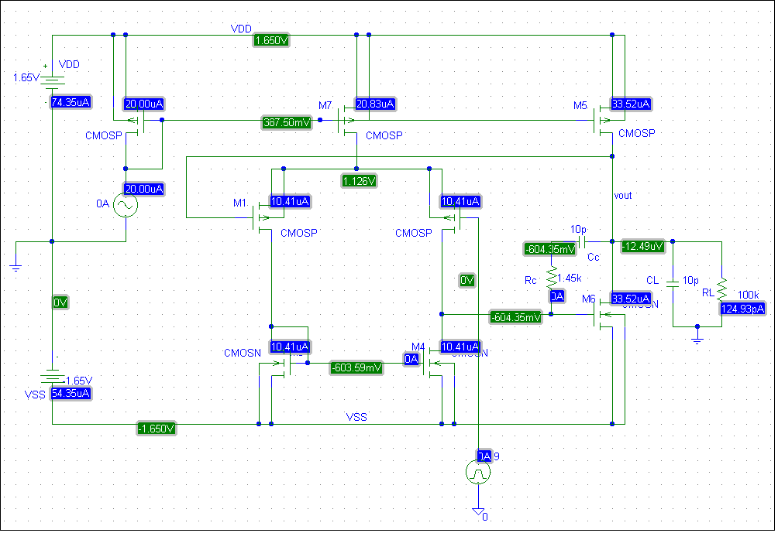

Circuit - Op Amp

Plot 1 - AC Analysis (Bode Plot):

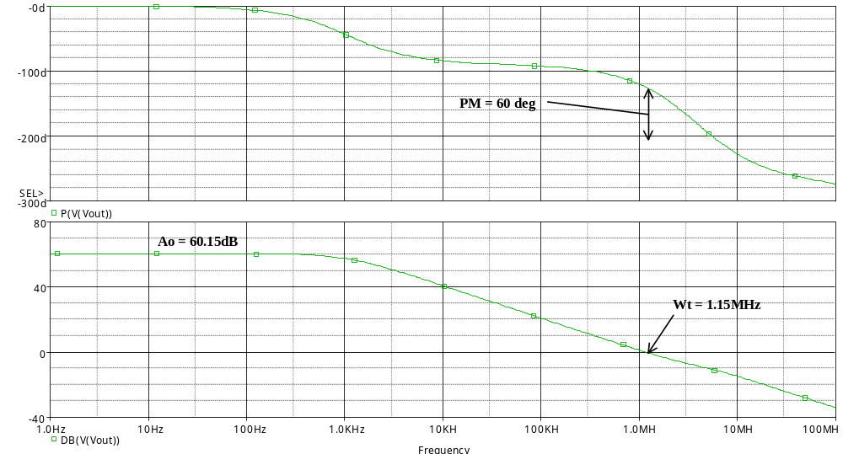

Plot 1 - AC Analysis (Bode Plot)

Plot 2 - DC Sweep (DC Voltage Gain):

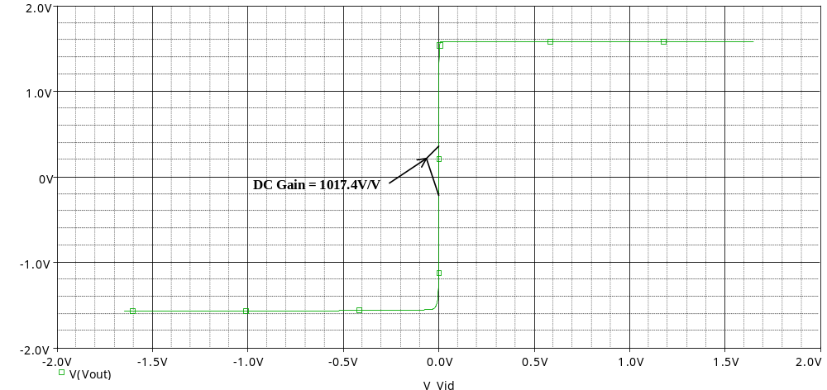

Plot 2 - DC Sweep (DC Voltage Gain)

Plot 3 - Transient Analysis (Slew Rate Falling):

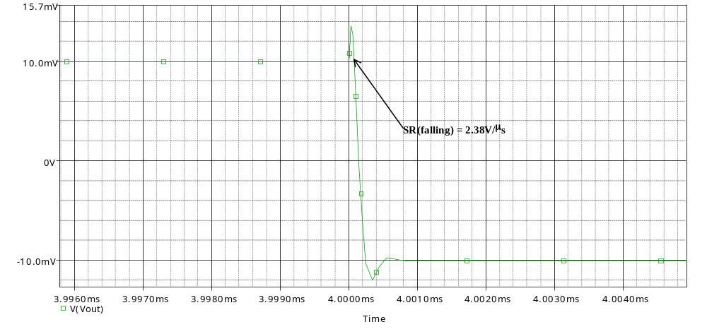

Plot 3 - Transient Analysis (Slew Rate Falling)

Plot 4 - Transient Analysis (Slew Rate Rising):

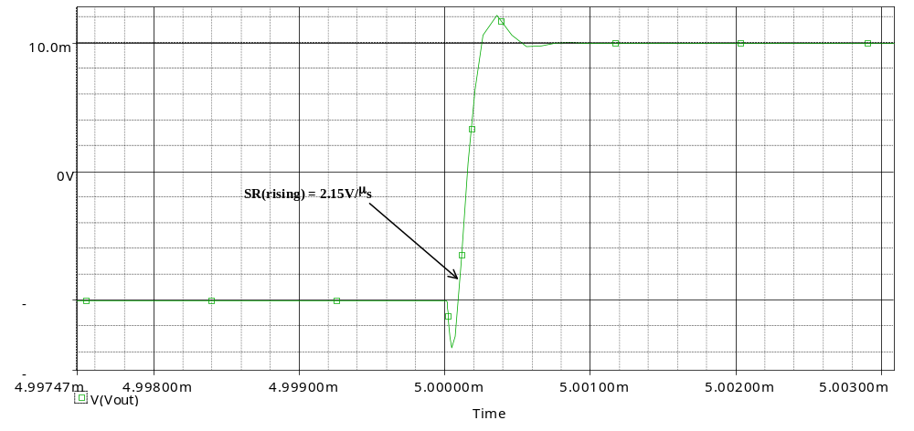

Plot 4 - Transient Analysis (Slew Rate Rising)

Comments

This proved to be a very challenging project reinforcing the concepts taught in class through real-world applications. In the completion of this project, working with fellow classmates proved to be very beneficial as it would in the real world. Unfortunately, due to time constraints, I was not able to complete this design to the level I would have liked, however it remains a very beneficial assignment to my understanding of microelectronics and their design process in real-life application.

